LAB 1
Wania Zanib
23-NTU-CS-1289
BSAI 5th
Embedded IoT Systems

Platformio.ini
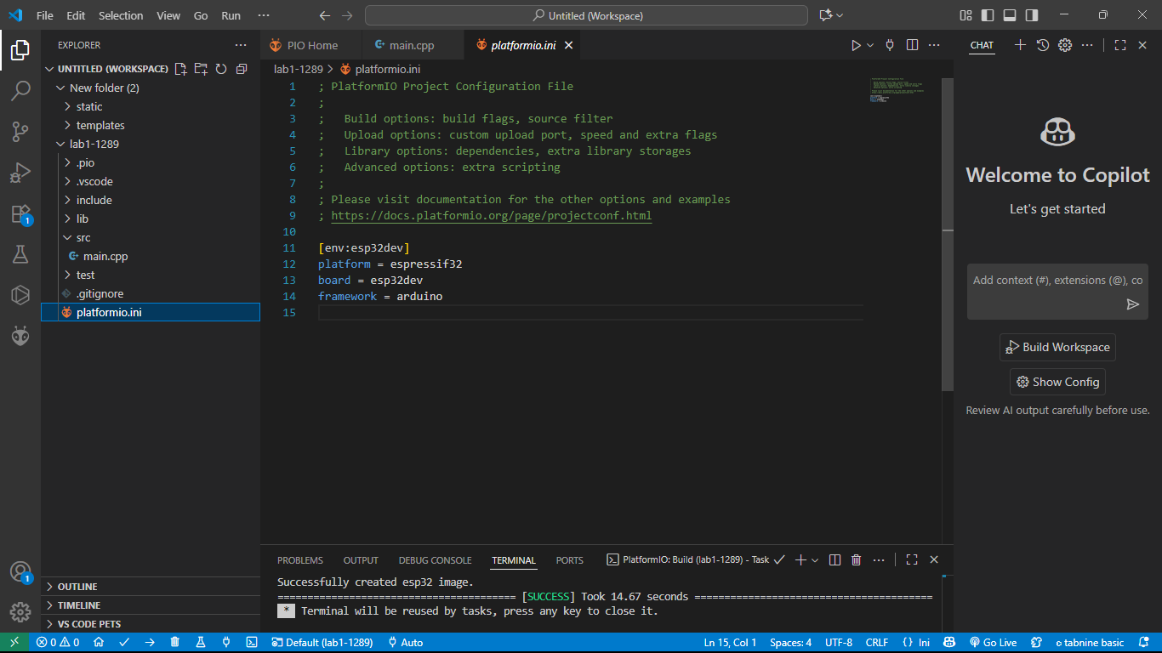

Main.cpp
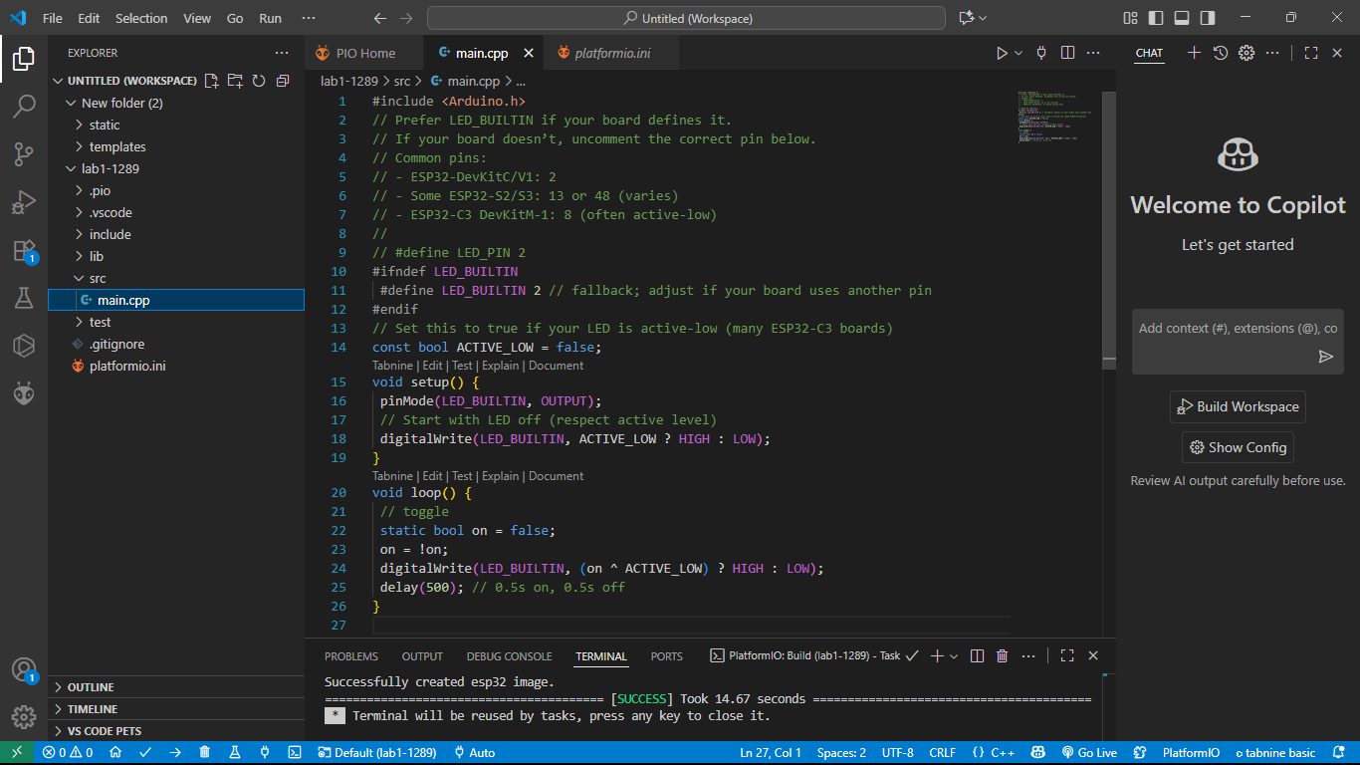

After Building:
